HandsMen Threads: Salesforce Bespoke Tailoring Order & Customer Management System

User story :
HandsMen Threads is a Salesforce-based application built so that customers, sales managers, inventory managers, marketing teams, and administrators can handle the entire bespoke tailoring order process in one unified platform. As a customer, I want to receive an email as soon as my order is confirmed, so that I know my bespoke garment is being processed without calling the store. As a sales manager, I want customer and order data stored in one place, with the system rejecting incorrect amounts, invalid quantities, and badly formatted emails, so that I can confirm orders accurately and without manual checking. As an inventory manager, I want automatic alerts when stock drops below five units and a scheduled job that updates inventory every night, so that popular products never run out unnoticed. As a marketing team member, I want customer loyalty tiers (Gold, Silver, Bronze) to update automatically from purchase history and campaigns to be linked to customers, so that I can offer personalized rewards and promote repeat business. As an administrator, I want a secure, role-based data model with reports and dashboards, so that every team sees only what it needs and management can make informed decisions about sales, stock, and customer engagement.

1. INTRODUCTION

1.1 Project Overview :
HandsMen Threads, a dynamic organization in the fashion industry, is building a premium fashion platform to streamline men's bespoke tailoring and enhance the customer experience through personalized styling and seamless order management. The project brings all customer, product, order, inventory, and marketing campaign data together in a single Salesforce application, ensuring a smooth flow of information across the organization. Sales teams manage customers and orders, inventory teams monitor stock, and marketing teams run campaigns, while managers gain full transparency into orders, stock levels, and customer loyalty.
Using Salesforce custom objects, Validation Rules, Flows, Apex Triggers, Batch Apex, Email Alerts, Reports, and Dashboards, the company can make sure that every stage of the order journey, from customer registration and order placement to confirmation, stock update, and loyalty reward, is handled systematically. Validation Rules maintain data integrity directly from the user interface by blocking incorrect amounts, invalid quantities, and badly formatted emails. Flows automate order confirmation emails, low-stock alerts, and loyalty status updates, while scheduled Apex processes bulk orders every night at midnight, updating financial records and adjusting inventory.

1.2 Purpose:
The primary purpose of HandsMen Threads is to replace manual and fragmented order, stock, and customer handling with a scalable, automated, and secure Salesforce solution that brings speed, accuracy, and personalization to the company's bespoke tailoring operations. The system ensures:
- Centralized business data management: All customer profiles, products, orders, inventory records, and campaigns are stored in one place, reducing duplication and data entry errors.
- Data integrity from the UI: Validation Rules check order amounts, stock quantities, and customer emails at the point of entry, so accurate and consistent data supports reliable decisions.
- Automated customer communication: Customers receive an email update after an order is confirmed, which strengthens engagement and customer relations.
- Dynamic loyalty program: Customer loyalty status (Gold, Silver, Bronze) is updated from purchase history, enabling personalized rewards and repeat business.
- Proactive stock management: When stock falls below five units, the warehouse team is notified automatically, preventing stock-outs and supporting timely restocking.
- Scheduled bulk processing: A nightly job at midnight processes bulk orders and adjusts inventory so that stock levels are accurate for the next day's operations.
- Secure, role-based access: Roles, profiles, and permission sets give each team access only to the data it needs.

2. IDEATION PHASE

2.1 Problem Statement (Customer Problem Statement Template)
PS (Customer) | I'm trying to | But | Because | Which makes me feel
PS-1 Sales Manager | Manage bespoke orders and confirm them accurately | Order details and statuses are scattered across notebooks and spreadsheets | Systems are manual and unintegrated | Frustrated and error-prone
PS-2 Inventory Manager | Keep products in stock for customer orders | I discover low stock only after items run out | There are no automatic stock alerts | Stressed and reactive
PS-3 Marketing Team | Reward loyal customers and run targeted campaigns | I cannot see purchase history or loyalty levels | Customer data is not centralized in one platform | Uncertain in decision-making
PS-4 Customer | Place a bespoke order and know its status | I don't know whether my order is confirmed | There is no automated confirmation or notification | Anxious and uninformed

2.2 Empathy Map Canvas
User Persona: Sales Manager
- Think & Feel: Worried about wrong order amounts, unconfirmed orders, and customers waiting for updates. Feels pressured to keep bespoke order records accurate while handling a growing number of customers.
- Hear: Customers asking whether their orders are confirmed, warehouse staff reporting items running out, and management asking for sales numbers and loyalty details.
- See: Scattered order notes, spreadsheets, and separate customer files, with no single view of order status or stock levels.
- Say & Do: Rechecks quantities and amounts, calls customers manually to confirm orders, chases the warehouse for stock, and updates records by hand.

2.3 Brainstorming & Idea Prioritization

Step 1: Brainstormed Ideas
- Spreadsheet tracking: Use shared spreadsheets and macros to track customers, orders, and stock more consistently.
- Standalone order portal: Build a custom web application where customers place bespoke orders online.
- Off-the-shelf ERP or inventory software: Adopt a ready-made package for orders and inventory management.
- Salesforce-based order management system: Build a unified cloud application using custom objects, Flows, Apex, Validation Rules, Reports, and Dashboards.
- Automated notifications: Send order confirmation emails to customers and low-stock alerts to the warehouse team.
- Dynamic loyalty program and scheduled processing: Update loyalty status from purchase history and run nightly bulk order and inventory updates.

Step 2: Grouping
Group | Ideas | Description
Manual solutions | Spreadsheet tracking | Low cost and quick to start, but still depends on manual updates and is prone to duplicate and inconsistent entries
Semi-automated solutions | Standalone order portal, off-the-shelf ERP or inventory software | Automate parts of the process, but often need separate systems, heavy customization, or complex integration
Fully automated cloud solutions | Salesforce-based order management, automated notifications, dynamic loyalty program and scheduled processing | End-to-end automation of validation, confirmation, stock alerts, loyalty updates, and reporting on one scalable platform

Step 3: Idea Prioritization
Each idea is rated High, Medium, or Low against the criteria below.
Idea | Impact | Feasibility | Cost Efficiency
Spreadsheet tracking | Low | High | High
Standalone order portal | Medium | Medium | Low
Off-the-shelf ERP or inventory software | Medium | Low | Low
Salesforce-based order management system | High | High | High
Automated notifications | High | High | High
Dynamic loyalty program and scheduled processing | High | Medium | High

3. REQUIREMENT ANALYSIS PHASE

3.1 Customer Journey Map
The journey map follows a customer and the HandsMen Threads staff through the order process, from first contact to loyalty rewards.

Stage 1: Awareness & Registration
- User Actions: Learns about HandsMen Threads and registers as a customer.
- Touchpoints: Website, showroom, sales team.
- Pain Points: Manual data entry, duplicate or incomplete customer details.
- HandsMen Threads Solution: The customer record is created in Salesforce, with email and phone fields and a validation rule that checks the email format.
- Emotion: Curious and hopeful.

Stage 2: Product Selection
- User Actions: Browses the bespoke range and checks product details, price, and availability.
- Touchpoints: Product catalog, sales team.
- Pain Points: Outdated product information and unclear stock availability.
- HandsMen Threads Solution: The HandsMen Product object stores name, SKU, price, and stock quantity in one place.
- Emotion: Interested but unsure.

Stage 3: Order Placement
- User Actions: Places an order for the selected product and quantity.
- Touchpoints: Sales team, order form.
- Pain Points: Paper notes, wrong amounts, and invalid quantities.
- HandsMen Threads Solution: Each order becomes a HandsMen Order record linked to the customer, with validation rules and an Apex trigger that block invalid amounts and quantities.
- Emotion: Anxious.

Stage 4: Order Confirmation
- User Actions: Waits for the order to be confirmed.
- Touchpoints: Sales manager, email.
- Pain Points: No visibility of status and delayed confirmation.
- HandsMen Threads Solution: When the order status changes to Confirmed, a record-triggered flow sends an automatic confirmation email to the customer.
- Emotion: Impatient, then relieved.

Stage 5: Stock Update & Fulfilment
- User Actions: The order is fulfilled while stock levels are updated.
- Touchpoints: Warehouse team, inventory records.
- Pain Points: Stock-outs are noticed late and inventory is updated by hand.
- HandsMen Threads Solution: A stock alert flow emails the warehouse team when quantity falls below five, and a nightly batch job updates inventory.
- Emotion: Reassured.

Stage 6: Loyalty & Retention
- User Actions: Receives loyalty recognition and promotional offers.
- Touchpoints: Loyalty email, marketing campaigns.
- Pain Points: Loyalty is tracked manually and rewards are generic.
- HandsMen Threads Solution: A scheduled flow sets Gold, Silver, or Bronze status from total purchases, and campaigns are linked to customers.
- Emotion: Valued and loyal.

Stage 7: Reporting & Follow-up
- User Actions: Management reviews orders, stock, and customer activity.
- Touchpoints: Dashboards, reports.
- Pain Points: Delayed and inaccurate reporting.
- HandsMen Threads Solution: Reports and Dashboards track orders, stock, and loyalty distribution.
- Emotion: Satisfied and confident.

3.2 Solution Requirements

Functional Requirements

FR-1: Customer Management
- Description: Manage customer records.
- Details: Create, update, and view customer profiles with name, email, phone, loyalty status, and total purchases. A formula field shows the full name, and a validation rule checks the email.

FR-2: Product & Inventory Management
- Description: Maintain the product catalog and stock levels.
- Details: Store product name, SKU, price, and stock quantity, and track inventory by warehouse. A formula field shows Available or Low Stock, and a validation rule blocks stock quantities of zero or less.

FR-3: Order Processing
- Description: Create, validate, and confirm orders.
- Details: Each order is linked to a customer and has a status of Pending, Confirmed, or Rejection. Validation rules and an Apex trigger enforce a valid amount and the quantity rules for each status.

FR-4: Loyalty Program
- Description: Update customer loyalty status.
- Details: A scheduled flow assigns Gold, Silver, or Bronze based on total purchases, supporting personalized rewards and repeat business.

FR-5: Automated Notifications
- Description: Send emails and alerts.
- Details: An order confirmation email goes to the customer when an order is confirmed, and a low-stock email goes to the warehouse team when stock falls below five units.

FR-6: Scheduled Bulk Processing
- Description: Run nightly batch jobs.
- Details: A scheduled Apex batch job runs daily at midnight to process bulk orders and update inventory, so stock levels stay accurate.

FR-7: Marketing Campaign Management
- Description: Manage promotions and campaigns.
- Details: Campaigns store a name, start date, and end date, and are linked to customers through a lookup relationship.

FR-8: Reporting
- Description: Reports and dashboards.
- Details: Track orders by status, customers by loyalty tier, low-stock inventory, and campaign activity from the Lightning app.

Non-Functional Requirements

NFR-1: Security
- Description: Protect customer and order data.
- Details: Profiles, roles, and permission sets give each user access only to the information they need.

NFR-2: Usability
- Description: Simple and consistent user experience.
- Details: A clean Lightning App with dedicated tabs that sales, inventory, and marketing users can use with minimal training.

NFR-3: Performance
- Description: Fast processing of order operations.
- Details: Records, flows, and reports run quickly, and batch jobs process data in scopes of 200 records.

NFR-4: Scalability
- Description: Support growth in customers, products, and orders.
- Details: The cloud platform handles increasing data volume and users without redesign.

NFR-5: Reliability and Availability
- Description: Dependable access to the system.
- Details: The Salesforce cloud platform provides high uptime and automatic data backup.

NFR-6: Data Accuracy
- Description: Consistent and correct data.
- Details: Validation rules, formula fields, and automation reduce manual errors.

3.3 Data Flow Diagram
This is the Level-1 data flow diagram for the main steps of the system.
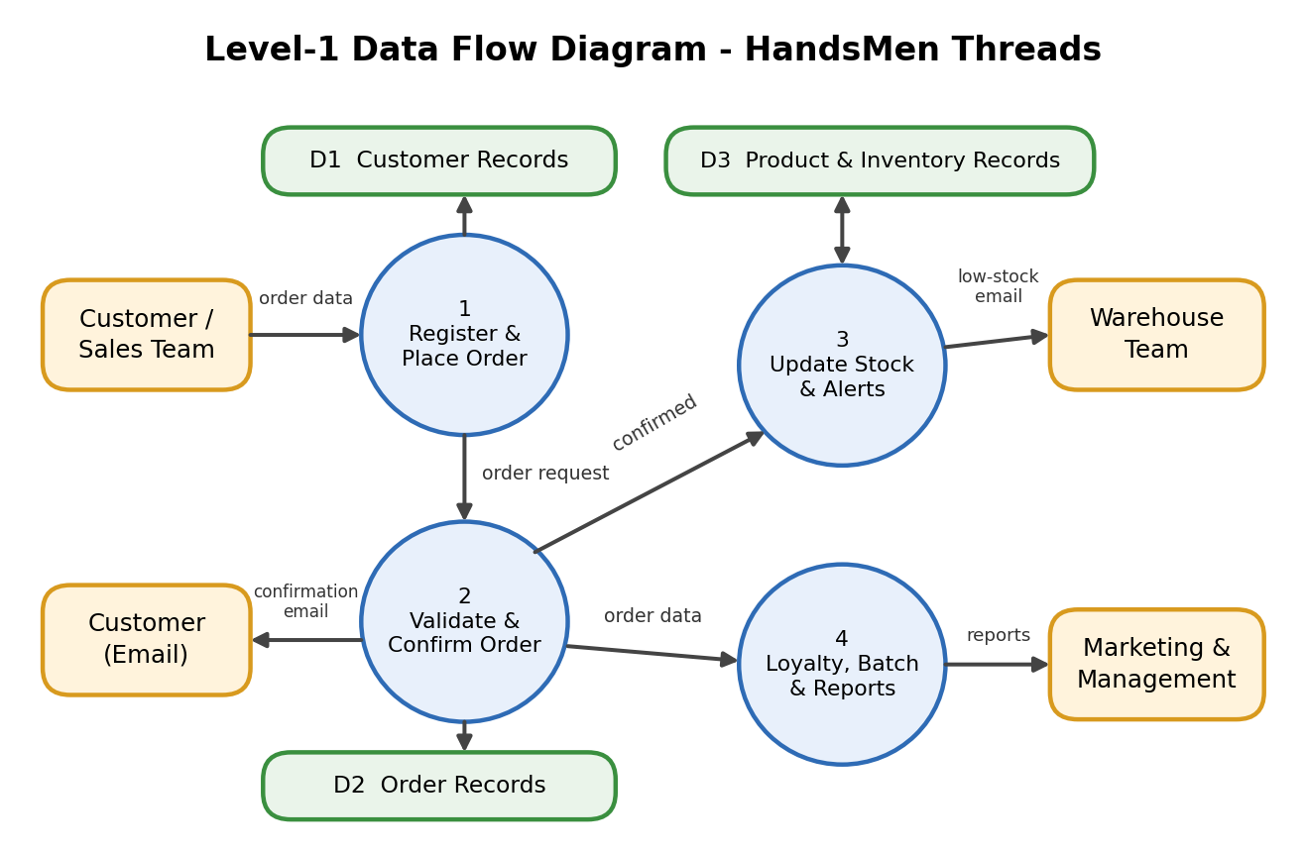
Here is how the diagram maps to the steps:
- Step 1, input: The customer or sales team submits customer and order data into process 1.
- Step 2, validation and storage: Process 1 checks the data and saves it to D1 (customer records) and passes the order request to process 2, which validates it and keeps the order and its status in D2.
- Step 3, confirmation: When the order is confirmed, process 2 sends a confirmation email to the customer and passes the confirmed order to process 3.
- Stock update and alerts: Process 3 updates D3 (product and inventory records) and sends a low-stock email to the warehouse team when quantity falls below five.
- Step 4, loyalty, batch and reports: Process 4 reads the order data, updates loyalty status, runs the nightly batch update, and feeds reports and dashboards for marketing and management.

4. PROJECT DESIGN PHASE

4.1 Problem-Solution Fit
HandsMen Threads directly addresses fragmented tailoring order workflows by aligning user behavior, constraints, and automation using Salesforce-native capabilities.

Problem Statement
Fashion and bespoke tailoring businesses often manage customer details, orders, and stock through separate notebooks, spreadsheets, and phone calls. This causes inaccurate order data, late stock-out discoveries, delayed confirmations, and no single view of business data. Sales teams spend time on manual checking, warehouse teams react late to low stock, marketing lacks loyalty insight, and customers are left waiting for updates.

Problem-Solution Mapping
Problem (User Behavior / Constraint) | HandsMen Threads Solution | Salesforce-Native Capability
Customer, order, and stock data scattered across notebooks and sheets | Centralized customer, product, order, and inventory records | Custom objects with lookup and master-detail relationships
Incorrect or badly formatted data entry | Data checked at the point of entry from the UI | Validation rules and Apex trigger validation
Customers unsure whether an order is confirmed | Automatic confirmation email when an order is confirmed | Record-triggered flow, email template, and email alert
Stock-outs discovered too late | Warehouse alerted when stock drops below five units; stock status shown on each record | Record-triggered flow and formula field
Manual tracking of customer loyalty | Loyalty status updated automatically from purchase history | Scheduled flow
Manual end-of-day order and inventory updates | Bulk orders processed and inventory adjusted every night at midnight | Batch Apex and Schedulable Apex
Unauthorized access to sensitive records | Users see only what their role permits | Profiles, permission sets, and roles
No visibility into sales and stock | Real-time tracking and management reporting | Reports, Dashboards, and Lightning App

4.2 Proposed Solution
Parameter | Description
Problem | Manual order, stock, and customer handling through notebooks, spreadsheets, and phone calls, leading to inaccurate data, late stock alerts, delayed confirmations, and unclear customer loyalty.
Solution | Salesforce-based HandsMen Threads application managing customers, products, orders, inventory, and campaigns, with automated confirmations, stock alerts, loyalty updates, and nightly batch processing on one platform.
Novelty | End-to-end automation of validation, notifications, loyalty tiers, and scheduled inventory updates using Salesforce-native tools (Flows, Apex Triggers, Batch Apex, Lightning).
Business Impact | Better customer experience through quick order confirmation, fewer stock-outs, personalized rewards, and less administrative effort.
Revenue Model | Higher repeat-purchase revenue through loyalty tiers and targeted campaigns, fewer lost sales from stock-outs, and lower manual processing cost.
Scalability | New products, warehouses, campaigns, and users can be added without redesign.

4.3 Solution Architecture
The architecture integrates Salesforce objects, automation, email services, reports, and security layers. Users interact through the Lightning interface, automation processes their requests, and the results are stored in custom objects. A security layer controls access at every level.
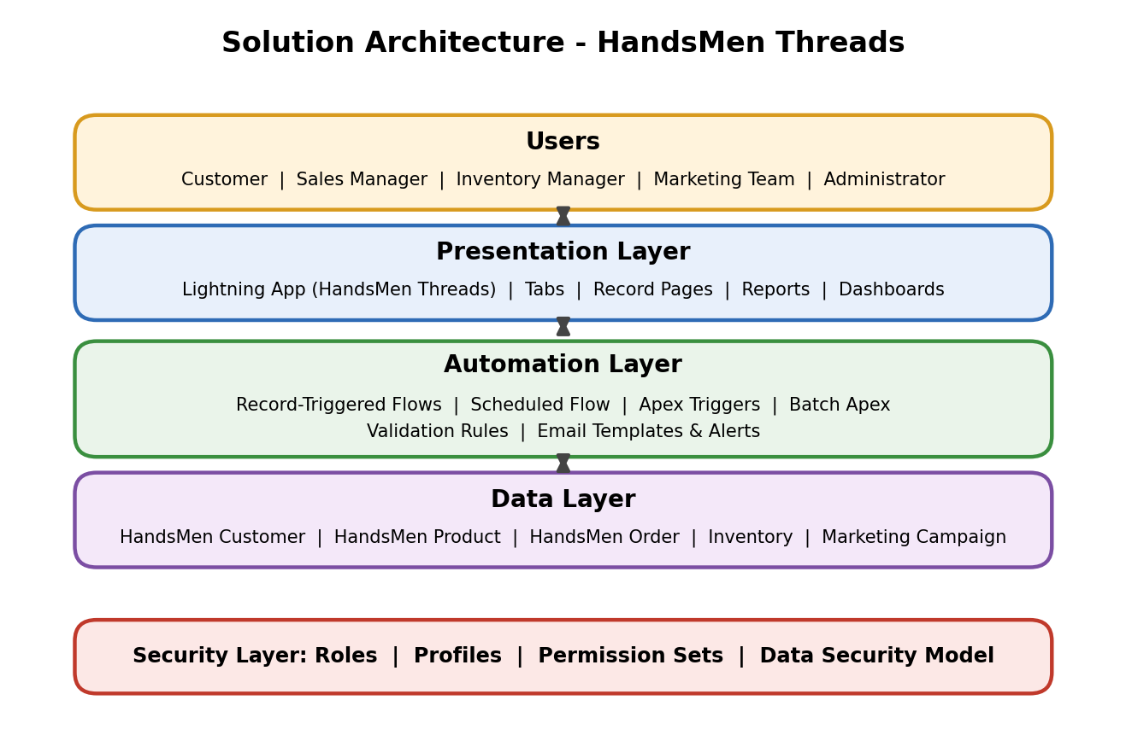
Here is how the layers work together:
- Users: Customers, sales managers, inventory managers, marketing teams, and administrators each get a role-specific view.
- Presentation layer: The HandsMen Threads Lightning app, tabs, reports, and dashboards give users a simple interface.
- Automation layer: Flows, Apex triggers, batch jobs, validation rules, and email alerts handle checking, notifications, and scheduled processing.
- Data layer: The HandsMen Customer, HandsMen Product, HandsMen Order, Inventory, and Marketing Campaign objects hold all records and their relationships.
- Security layer: Roles, profiles, and permission sets apply at every layer, so users see only the records and objects they are allowed to.

4.4 Object Model & Entity Relationship Diagram
Five custom objects hold the business data. The diagram shows how they relate, and the tables list each object with its key fields and the relationships that link them.
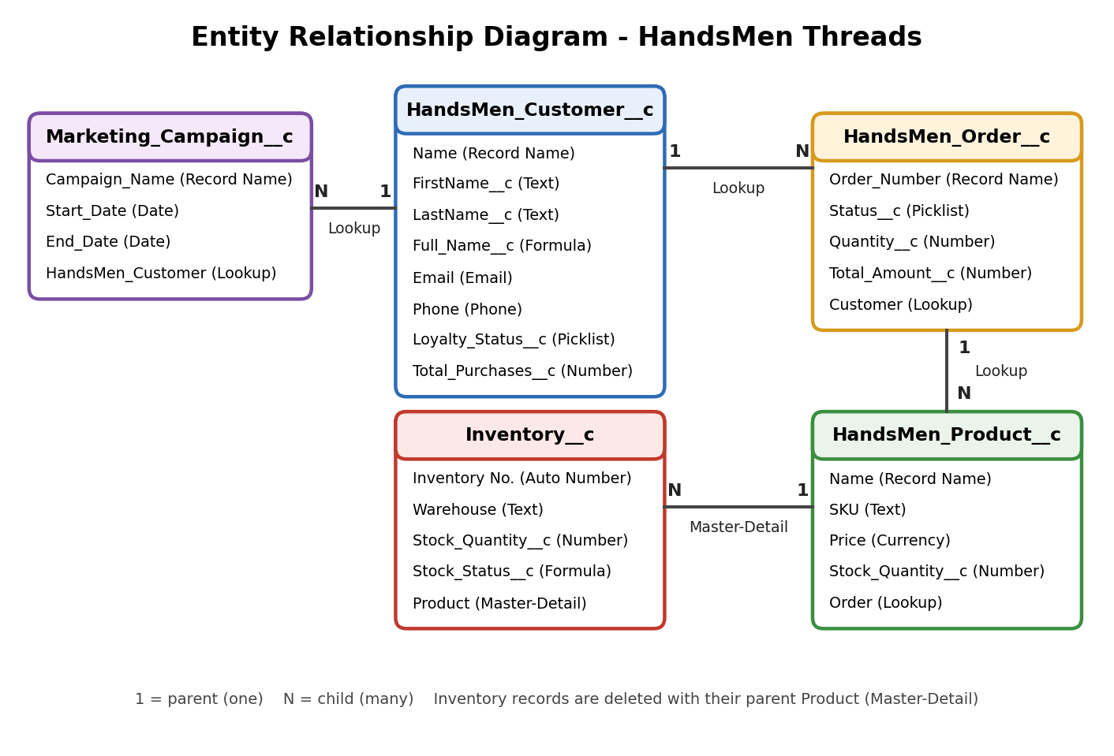
Object Name | Type | Description | Key Fields
HandsMen_Customer__c | Custom Object | Stores customer details | Name (Record Name), Email (Email), Phone (Phone), Loyalty_Status__c (Picklist: Gold, Silver, Bronze), Total_Purchases__c (Number), FirstName__c, LastName__c, Full_Name__c (Formula)
HandsMen_Product__c | Custom Object | Stores product catalog | Name (Record Name), SKU (Text), Price (Currency), Stock_Quantity__c (Number)
HandsMen_Order__c | Custom Object | Stores customer orders | Order_Number (Record Name), Status__c (Picklist: Pending, Confirmed, Rejection), Quantity__c (Number), Total_Amount__c (Number)
Inventory__c | Custom Object | Tracks inventory levels | Auto Number (Record Name), Warehouse (Text), Stock_Quantity__c (Number), Stock_Status__c (Formula)
Marketing_Campaign__c | Custom Object | Manages promotions and campaigns | Campaign_Name (Record Name), Start_Date (Date), End_Date (Date)

Child Object to Parent Object | Relationship Type | Field Label | Purpose
Marketing Campaign to HandsMen Customer | Lookup | HandsMen Customer | Links each campaign to a customer
HandsMen Product to HandsMen Order | Lookup | Order | Links products to the order that includes them
HandsMen Order to HandsMen Customer | Lookup | Customer | Links each order to the customer who placed it
Inventory to HandsMen Product | Master-Detail | Product | Ties stock records to their product, and deletes them with it

4.5 Automation Strategy
The table below summarizes the data-quality rules and automation components that make up the solution.
Component | Name | Trigger / Schedule | Purpose
Validation Rule | Total Amount (HandsMen Order) | On save: Total_Amount__c <= 0 | Blocks orders with a zero or negative amount
Validation Rule | Stock Quantity (Inventory) | On save: Stock_Quantity__c <= 0 | Blocks stock quantities of zero or less
Validation Rule | Email (HandsMen Customer) | On save: email does not contain @gmail.com | Requires a valid Gmail address
Record-Triggered Flow | Order Confirmation Flow | Order updated to Status = Confirmed | Sends the order confirmation email to the customer
Record-Triggered Flow | Stock Alert Flow | Inventory created or updated with Stock_Quantity__c < 5 | Emails the Inventory Manager a low-stock alert
Scheduled Flow | Loyalty Status Update Flow | Daily | Sets Gold, Silver, or Bronze from Total_Purchases__c
Apex Trigger | OrderTrigger (OrderTriggerHandler) | Before insert and before update on HandsMen Order | Enforces quantity rules for each order status
Apex Trigger | Update Order Total | Order save | Auto-updates Total_Amount__c
Apex Trigger | Stock Deduction | Inventory, when an order is placed | Reduces stock when an order is placed
Apex Trigger | Loyalty Status Update | Customer | Upgrades loyalty status based on purchases
Batch Apex | InventoryBatchJob | Scheduled daily at midnight | Updates inventory and restocks low-stock products
Batch Apex | Loyalty Points Calculation | Every Sunday, 12 AM | Updates customer points weekly
Batch Apex | Inventory Sync | Daily at 2 AM | Syncs stock levels with the external warehouse system

Section 6 documents the build of the validation rules, the three flows, the OrderTrigger with its handler class, and the InventoryBatchJob. The remaining triggers and the weekly and external-sync batch jobs are part of the solution design and can be added on the same pattern.

5. PROJECT PLANNING & SCHEDULING

5.1 Project Planning
The project follows the Agile methodology. Work is organized as Epics → User Stories → Story Points and delivered in sprints. Velocity from completed sprints is used to estimate the remaining work.

Alignment with Project Phases
Phase | Key Activities | Sprint Coverage
Phase 1: Architecture & Planning | Define objects, fields, relationships, and formula fields; plan validation rules, flows, Apex triggers, batch jobs, and email templates | Sprint-1 to Sprint-2
Phase 2: Development | Object and field creation, automation, data security and sharing, batch jobs, and email templates | Sprint-2 to Sprint-5
Phase 3: Testing & QA | Unit testing, end-to-end testing with sample data, performance and security checks | Sprint-3 to Sprint-6 (each story tested as delivered)
Phase 4: Deployment & Training | Deploy to production, train users, post-go-live support and monitoring | After Sprint-6

Product Backlog and Sprint Schedule
Sprint | Functional Requirement (Epic) | User Story Number | User Story / Task | Story Points | Priority
Sprint-1 | Developer Setup | USN-1 | As a system administrator, I want to create a Salesforce developer account so that I can configure and deploy the HandsMen Threads solution. | 1 | High
Sprint-1 | Data Modeling | USN-2 | As an admin, I want to create custom objects for HandsMen Customer, HandsMen Order, HandsMen Product, Inventory, and Marketing Campaign so that all business data is stored in one place. | 3 | High
Sprint-2 | Data Modeling | USN-3 | As a user, I want dedicated tabs for each object so that I can easily navigate between customers, orders, products, inventory, and campaigns. | 3 | High
Sprint-2 | Data Modeling | USN-4 | As a sales manager, I want a centralized Lightning App named HandsMen Threads so that I can access all business operations from one interface. | 3 | High
Sprint-2 | Data Modeling | USN-5 | As an admin, I want to create fields such as email, phone, loyalty status, total purchases, order status, quantity, and SKU so that complete records can be captured accurately. | 5 | High
Sprint-2 | Data Modeling | USN-6 | As an admin, I want lookup and master-detail relationships between customers, orders, products, inventory, and campaigns so that records are logically linked. | 5 | High
Sprint-2 | Data Modeling | USN-7 | As a user, I want formula fields for Full Name and Stock Status so that key information is calculated and displayed automatically. | 3 | Medium
Sprint-3 | Data Quality | USN-8 | As a system, I want validation rules on order amount, stock quantity, and customer email so that incorrect data is blocked at the point of entry. | 3 | High
Sprint-3 | Automation | USN-9 | As a sales manager, I want email templates and alerts for order confirmation, low stock, and loyalty rewards so that customers and the warehouse team are informed automatically. | 3 | High
Sprint-3 | Automation | USN-10 | As an administrator, I want record-triggered and scheduled flows for order confirmation, stock alerts, and loyalty status so that manual effort is reduced. | 5 | High
Sprint-4 | Apex & Async | USN-11 | As a sales manager, I want an Apex trigger that enforces order quantity rules by status so that invalid orders cannot be saved. | 5 | High
Sprint-4 | Apex & Async | USN-12 | As an inventory manager, I want a scheduled batch job that updates inventory every night so that stock levels stay accurate for daily operations. | 5 | High
Sprint-5 | Security | USN-13 | As an admin, I want profiles, roles, users, and permission sets so that users can only access data relevant to their responsibilities. | 5 | High
Sprint-6 | Reports & Dashboards | USN-14 | As a manager, I want reports on orders, customer loyalty, and low-stock inventory so that I can monitor business operations. | 4 | Medium
Sprint-6 | Reports & Dashboards | USN-15 | As a manager, I want dashboards showing sales and stock trends so that I can quickly analyze business performance. | 4 | Medium

Epic Summary
Epic | Stories | Story Points
Developer Setup | USN-1 | 1
Data Modeling | USN-2 to USN-7 | 22
Data Quality | USN-8 | 3
Automation | USN-9 to USN-10 | 8
Apex & Async | USN-11 to USN-12 | 10
Security | USN-13 | 5
Reports & Dashboards | USN-14 to USN-15 | 8
Total | 15 stories | 57

6. Project Development Phase

Milestone 1: Salesforce Developer Account Creation
Definition: A free Salesforce Developer Edition org is the working environment where the whole HandsMen Threads solution is built, tested, and demonstrated. It gives full access to the platform without affecting any production system.
Key steps:
- Go to developer.salesforce.com/signup
- Enter first name, last name, email, Role (Developer), Company (college name), Country (India), postal code, and a username in the form name@organization.com (it need not be a real email)
- Click Sign me up, open the verification email (it can take 5 to 10 minutes), and click Verify Account
- Set a password, answer the security question, and open Setup from the gear icon

Milestone 2: Custom Object Creation (HandsMen Customer, HandsMen Order, HandsMen Product, Inventory, Marketing Campaign)
Definition: A custom object is a database table in Salesforce. Five objects store the core business data: HandsMen Customer, HandsMen Order, HandsMen Product, Inventory, and Marketing Campaign.
Key steps:
- Setup > Object Manager > Create > Custom Object
- Enter the label and plural label (for example, HandsMen Customer), then set the Record Name label and data type (Text, or Auto Number for Inventory)
- Tick Allow Reports and Allow Search, then Save
- Repeat for the other four objects

Milestone 3: Tabs Creation
Definition: A tab is a navigation shortcut that opens an object's list of records. Dedicated tabs let users move quickly between customers, orders, products, inventory, and campaigns.
Key steps:
- Setup > Tabs > Custom Object Tabs > New
- Select the object (for example, HandsMen Customer) and choose a tab style
- Keep the default profile visibility and custom app settings, then Save
- Repeat for the other objects

Milestone 4: Lightning App Creation
Definition: A Lightning App groups tabs and utilities into one branded workspace. The HandsMen Threads app gives the team a single interface for all business operations.
Key steps:
- Setup > App Manager > New Lightning App
- Enter the App Name (HandsMen Threads), a meaningful description, an optional image, and keep the default primary color
- Keep the default app options and utility items
- Add the navigation items: HandsMen Customer, HandsMen Order, Inventory, HandsMen Product, Reports, Dashboard, Account, Contact, and Marketing Campaign
- Assign the System Administrator profile, then Save & Finish

Milestone 5: Fields Creation
Definition: Fields are the columns of an object, and each holds one piece of data. They capture customer details, product information, order status, and stock levels accurately.
Key steps:
- Object Manager > (object) > Fields & Relationships > New
- HandsMen Customer: Email (Email), Phone (Phone), Loyalty Status (Picklist: Gold, Silver, Bronze), Total Purchases (Number), FirstName and LastName (Text)
- HandsMen Order: Status (Picklist: Pending, Confirmed, Rejection), Quantity (Number), Total Amount (Number)
- HandsMen Product: SKU (Text), Price (Currency), Stock Quantity (Number)
- Inventory: Warehouse (Text), Stock Quantity (Number). Marketing Campaign: Start Date and End Date (Date)

Milestone 6: Create Relationships
Definition: Relationships link records across objects. A Lookup field connects two objects loosely, while a Master-Detail field makes the child record depend on its parent.
Key steps:
- Marketing Campaign: create a Lookup to HandsMen Customer (field label HandsMen Customer)
- HandsMen Product: create a Lookup to HandsMen Order (field label Order)
- HandsMen Order: create a Lookup to HandsMen Customer (field label Customer)
- Inventory: create a Master-Detail relationship to HandsMen Product (field label Product)
- Check the related lists on the parent records

Milestone 7: Formula Fields
Definition: A formula field calculates its value automatically from other fields, so users never have to enter or update it by hand.
Object | Field | Return Type | Formula
Inventory__c | Stock_Status__c | Text | IF(Stock_Quantity__c > 10, "Available", "Low Stock")
HandsMen_Customer__c | Full_Name__c | Text | FirstName__c + " " + LastName__c

Key steps:
- Create FirstName and LastName on HandsMen Customer before the full name formula
- Object Manager > (object) > Fields & Relationships > New > Formula, choose the return type, and use Check Syntax before saving

Milestone 8: Validation Rules
Definition: A validation rule is a formula that blocks a record from being saved when data is wrong, for example a zero order amount, a non-positive stock quantity, or an email that is not a Gmail address. This maintains data integrity directly from the UI.
Object | Rule Name | Error Condition Formula | Error Message and Location
HandsMen_Order__c | Total Amount | Total_Amount__c <= 0 | "Please Enter Correct Amount", shown on the Total Amount field
Inventory__c | Stock Quantity | Stock_Quantity__c <= 0 | "The inventory count is never less than zero.", shown at the top of the page
HandsMen_Customer__c | Email | NOT CONTAINS(Email, "@gmail.com") | "Please fill Correct Gmail", shown at the top of the page

Key steps:
- Object Manager > (object) > Validation Rules > New
- Enter the rule name, write the error condition formula, and enter the error message and its location
- Activate and test with invalid data

Milestone 9: Profiles, Roles & Users
Definition: Profiles control what objects a user can work with, roles control record visibility through the hierarchy, and users are the people who log in with a profile and a role.
Key steps:
- Setup > Profiles: clone the Standard User profile, name it Platform 1, click Edit, give access to the HandsMen Product and Inventory objects under Custom Object Permissions, and Save
- Setup > Roles > Set Up Roles > Expand All > Add Role under CEO: create Sales, Inventory, and Marketing roles
- Setup > Users > New User: create Niklaus Mikaelson (Role: Sales) and Kol Mikaelson (Role: Inventory), each with the Salesforce Platform license and the Platform 1 profile
- Create two more users in the same way for the remaining roles

Milestone 10: Permission Sets & Data Security Model
Definition: A permission set adds object access on top of a user's profile. Together with roles, it enforces the data security model of the project.
Data security model:
Role | Access Level
Sales Manager | Full access to Customers and Orders
Inventory Manager | Read and Edit on Inventory and Products
Marketing Team | Read on Customers, Edit on Marketing Campaigns

Key steps:
- Setup > Permission Sets > New, label it Permission_Platform_1, and Save
- Under Apps, open Object Settings, select HandsMen Customer, click Edit, tick Read, Create, Edit, and Delete, and Save; repeat for HandsMen Order
- Click Manage Assignments > Add Assignment, select a user with the Platform 1 profile, then Next > Assign > Done

Milestone 11: Email Templates & Email Alert
Definition: An email template stores the standard wording of a message, and an email alert sends that template to a chosen recipient when automation calls it.
Template Name | Type | Trigger
Order Confirmation | HTML | Sent when an order is placed and confirmed
Low Stock Alert | Text | Sent when Inventory__c.Stock_Quantity__c < 5
Loyalty Program Email | HTML | Sent when a customer qualifies for loyalty rewards

Key steps:
- Setup > Classic Email Templates > New Template, then choose HTML (with Classic Letterhead) for formatted emails or Text for plain emails
- Select the Unfiled Public Email Templates folder, tick Available for Use, and keep UTF-8 encoding
- For Order Confirmation, use the name Order_Confirmation_Email, the subject "Your Order has been Confirmed!", and a body that greets the customer, states the order number, thanks them, and signs off as the Sales Team
- Create the Low Stock Alert and Loyalty Program Email templates in the same way
- Setup > Email Alerts > New Email Alert: description Order Confirmation Email Alert, object HandsMen Order, the template created above, and recipient type Related Record > Customer

Milestone 12: Flows (Automation)
Definition: Flow is Salesforce's declarative automation tool. Record-triggered flows react to data changes, and scheduled flows run at a set time, replacing manual work.
Key steps:
- Order Confirmation Flow: Setup > Flows > New Flow > Record-Triggered Flow on HandsMen Order, run when a record is updated with Status = Confirmed (only when the record is updated to meet the condition); add an Action to Send Email Alert (Order Confirmation Email Alert, Record ID {!$Record.Id}); Save and Activate
- Stock Alert Flow: Record-Triggered Flow on Inventory, run when a record is created or updated with Stock_Quantity__c < 5, every time it meets the condition; add an Action to Send Email Alert to the Inventory Manager; Save and Activate
- Loyalty Status Update Flow: Schedule-Triggered Flow that runs daily; Get Records for all HandsMen Customer records; Loop through them; a Decision sets Loyalty Status to Gold when Total Purchases is above 1000, Bronze when it is below 500, and Silver by default; add Update Records; Save and Activate

Milestone 13: Apex Class & Apex Trigger
Definition: Apex is Salesforce's programming language for logic that declarative tools cannot cover. A trigger runs on record events, and a handler class keeps the logic organized and reusable.
Order Status | Quantity Rule Enforced by the Handler
Confirmed | Quantity must be more than 500
Pending | Quantity must be more than 200
Rejection | Quantity must be 0

Key steps:
- Open the Developer Console from the gear icon, then File > New > Apex Class and name it OrderTriggerHandler
- Write the validateOrderQuantity method, which loops through the orders and adds an error to the Quantity field when a rule below is broken, then save
- File > New > Apex Trigger, name it OrderTrigger on HandsMen_Order__c, run it before insert and before update, and call the handler method, then save

Milestone 14: Batch Job & Scheduling (Asynchronous Apex)
Definition: Batch Apex processes large volumes of records in smaller chunks in the background. Combined with Schedulable Apex, it runs automatically at a set time, such as every night.
Batch Job | Purpose | Schedule
Inventory Batch Job (Daily Inventory Sync) | Updates stock levels and restocks low-stock products | Daily at midnight (cron 0 0 0 * * ?)
Loyalty Points Calculation | Updates customer points weekly | Every Sunday, 12 AM
Inventory Sync | Syncs stock levels with the external warehouse system | Daily at 2 AM

Key steps:
- Developer Console > File > New > Apex Class, name it InventoryBatchJob, implementing Database.Batchable and Schedulable
- start() selects products with Stock_Quantity__c below 10; execute() adds 50 units to each and updates them with error handling; finish() logs completion
- The scheduler method runs the batch with a scope of 200 records
- Debug > Open Execute Anonymous Window and run System.schedule('Daily Inventory Sync', '0 0 0 * * ?', new InventoryBatchJob()) to run it daily at midnight
- Confirm the job under Setup > Scheduled Jobs

Milestone 15: Reports & Dashboards
Definition: Reports are saved queries that list records by criteria and grouping, and dashboards display report data as charts and tables. Managers use them to monitor orders, stock, and loyalty.
Key steps:
- Reports > New Report, select a report type such as HandsMen Orders with Customers
- Build reports for orders by status, customers by loyalty status, and low-stock inventory; add filters, grouping, and columns, then save into a folder
- Dashboards > New Dashboard, add components from the saved reports, choose chart types, and set titles
- Save the dashboard and set the running user

Milestone 16: Conclusion

Project Summary
HandsMen Threads (the Salesforce-based bespoke tailoring order and customer management system) replaces the notebooks, spreadsheets, and manual follow-ups that previously held the process together. It brings customers, products, orders, inventory, and campaigns into one Salesforce platform, so everyone works from a single source of truth. Along the way, the project applied data modeling, data quality, Lightning App Builder, record-triggered flows, Apex and Apex triggers, and asynchronous Apex.

Outcomes and Benefits
- Efficiency: Less manual data entry, order chasing, and end-of-day inventory reconciliation.
- Accuracy: Validation rules and the order quantity trigger reduce incorrect, missing, and inconsistent records.
- Customer engagement: Automatic order confirmation emails keep customers informed and strengthen relationships.
- Stock availability: Low-stock alerts and nightly inventory updates help prevent stock-outs.
- Personalization: Loyalty tiers update automatically from purchase history, enabling targeted rewards and repeat business.
- Accountability and security: Every record and change is traceable in one system, and role-based access protects sensitive data.
- Scalability and maintainability: Because most of the solution uses standard Salesforce functionality, new products, warehouses, and users can be added through configuration.

Possible Future Enhancements
- Customer portal (for example, an Experience Cloud site) for online ordering, order tracking, and style preferences
- Bespoke measurement and styling records to store each customer's measurements, fabric choices, and fittings
- Mobile access through the Salesforce mobile app for showroom and warehouse staff
- SMS and WhatsApp notifications alongside email for order and loyalty updates
- Integrations with a payment gateway, an external warehouse system, and courier tracking
- Advanced analytics such as sales forecasting, stock planning, and customer lifetime value
- AI-assisted features, such as personalized style recommendations and restocking suggestions

Closing Statement
HandsMen Threads delivers on its core objectives: one platform, cleaner data, automated customer communication, proactive stock control, and a dynamic loyalty program. Its native, configuration-first design gives the organization a solid foundation to grow from.

Submitted By,
Dineesh M

